API GATEWAY WITH OCELOT
- What is an API Gateway?

API – Application Programming Interface – it is a way for one application to talk to another

In microservices – application is divided into small independent services
Each services ,runs independently, it might have its own database, has its own api
Now imagine ,if frontend needs
- User data -> calls user service
- Order data -> call order service
- Payment data -> calls payment service

Now the client cannot remember all these service endpoints to access the application, it will not be feasible. The frontend must call multiple services separately, this becomes messy

Definition: An API Gateway is a single-entry point for all client requests in microservices architecture., api gateway forwards request to correct service

Instead of:

Frontend → Multiple Services

It becomes:

Frontend → API Gateway → Multiple Services

4️⃣ Why Do We Need API Gateway?

Without API Gateway:
- Frontend must know all service URLs
- Security must be implemented in each service
- Logging must be implemented in each service
- Authentication must be duplicated
- Hard to manage versioning

With API Gateway:
✅ Single entry point
✅ Centralized authentication
✅ Centralized logging
✅ Centralized routing
✅ Load balancing
✅ Rate limiting
✅ Request transformation
Response Aggregation
Example:
Dashboard needs:
- User data
- Order count
- Payment summary
Instead of 3 calls from frontend:
Gateway calls 3 services → Combines response → Sends single response.

- Instead of checking JWT in every service, gateway validates token once
- Invalid token – Blocked immediately
- Load balancing – if you have 3 instances of order service, gateway distributes requests across them
- Rate Limiting- prevent abuse – only 100 requests per minute per user
- Logging&monitoring – all requests pass through gateway-> easy to monitor
Where does the API gateway sit?
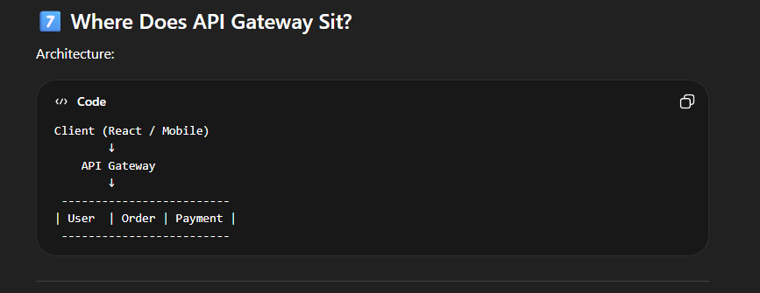

From our application
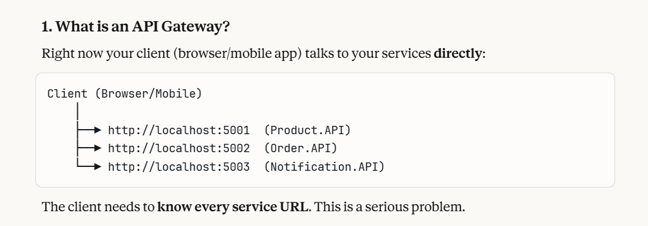

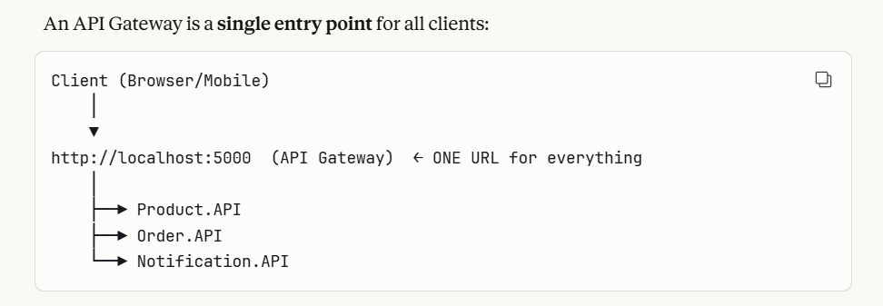

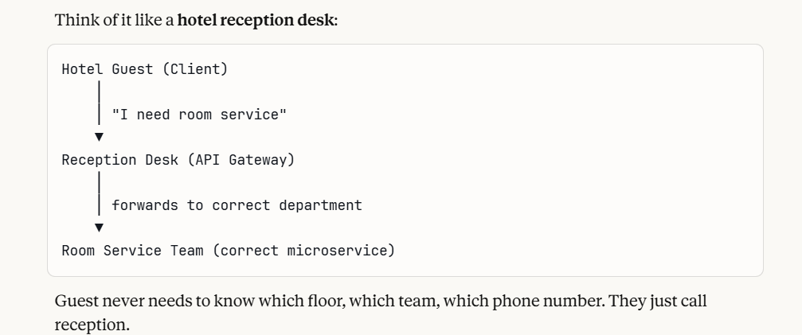

Problems without API Gateway
Prblm 1 : Client knows too much endpoints , if any url change or updated, users must update app
Prblm2: No central authentication, every service must validate jwt token individually, but with gateway, validates token once, if valid ,it forwards to service ,if invalid it rejects immediately, services trust gateway completely
Prblm3: CORS issues – without gateway, every service must configure cors separately, every service exposed to internet directly,security risk
With gateway, the gateway only is exposed to internet, all services hidden behind the gateway,one cors configuration
Prblm 4 : No rate limiting- without gateway the malicious users sends 1lac requests/second, directly hits your services , it gets crashed
With gateway, it detects the abuse, blocks after x requests per second ,services are protected
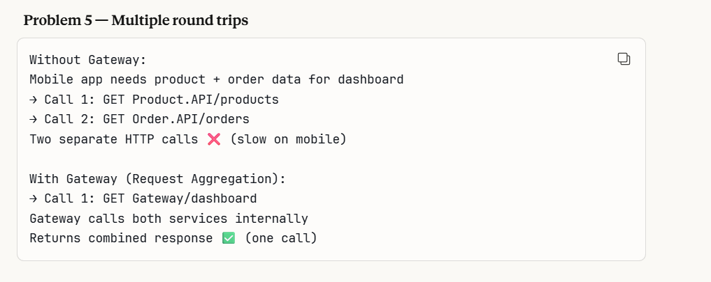

WHAT IS OCELOT?

- Ocelot is a open source .Net API Gateway library built specifically for .Net microservices
Without Ocelot → build routing, auth, rate limiting yourself (weeks of work)
With Ocelot → configure in JSON file (hours of work) ✅
- It works as a middleware in the ASP.net core
- Other popular API gateway options are
- Kong – used widely in enterprise systems
- NGINX – can be configured as reverse proxy,high performance
- AWS API gateway – integrate with AWS lambda, good for serverless
- Azure API management -Developer portal
- YARP – good alternative in .net
1️⃣1️⃣ Difference: API Gateway vs Reverse Proxy
Reverse Proxy , eg Nginx , yarp
- Forwards requests
- Basic routing
- Load balancing
API Gateway
- Routing
- Authentication
- Rate limiting
- Logging
- Aggregation
- API versioning
👉 API Gateway = Reverse Proxy + Advanced API features
Why API Gateway?
Answer:
- To provide a single entry point
- To handle cross-cutting concerns
- To improve security
- To simplify client communication
- To enable microservices scalability

From our application
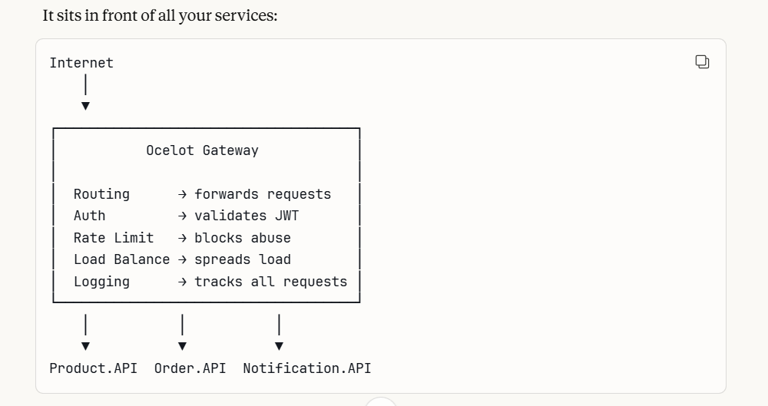
4. Key Ocelot Concepts – very important
1. UPSTREAM VS DOWNSTREAM
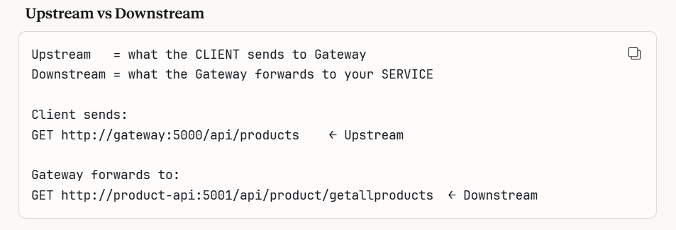
- Route – A route is a mapping rule in ocelot
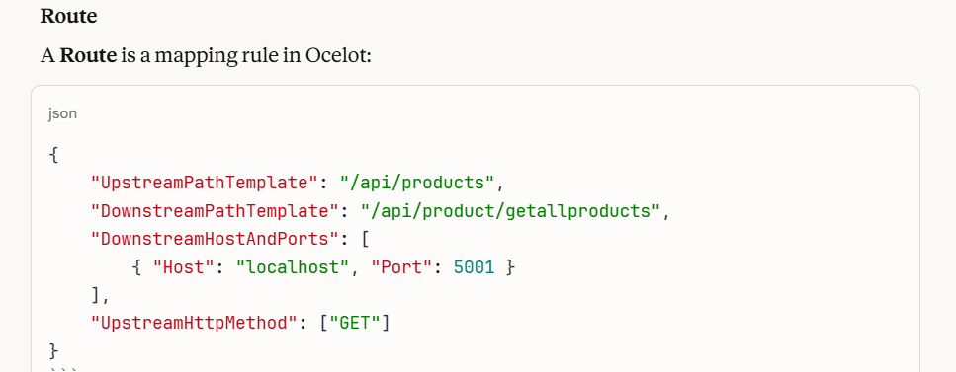

Ocelot.json – this is the heart of ocelot, a json configuration file where you define all routes, no code needed for routing – just configuration(refer screenshot below)
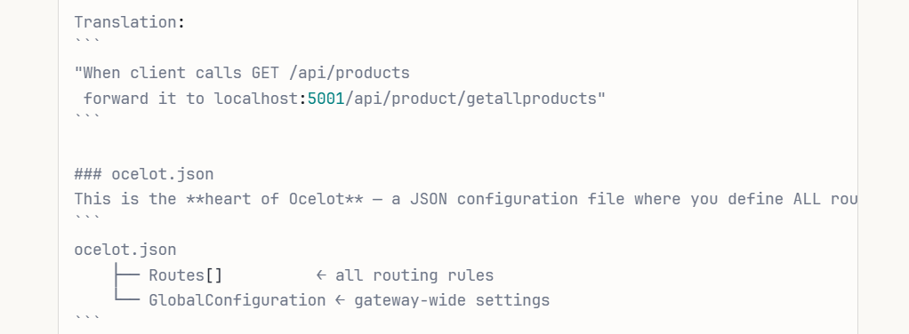
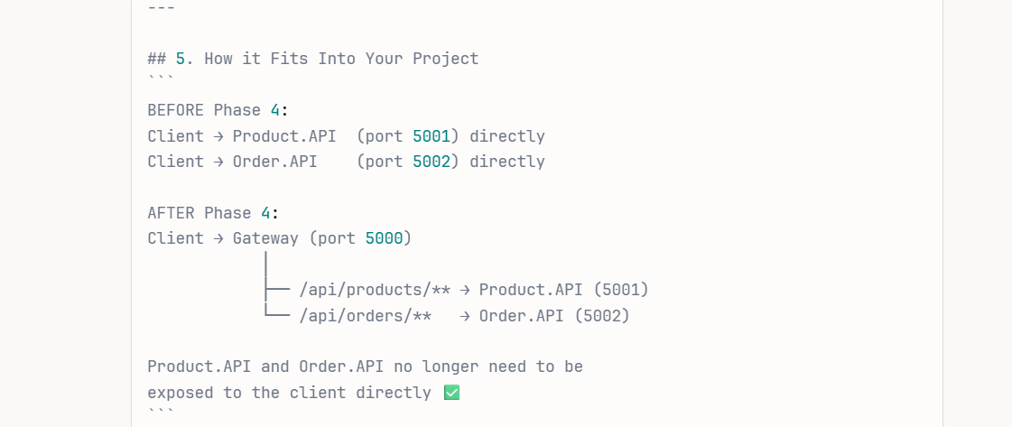
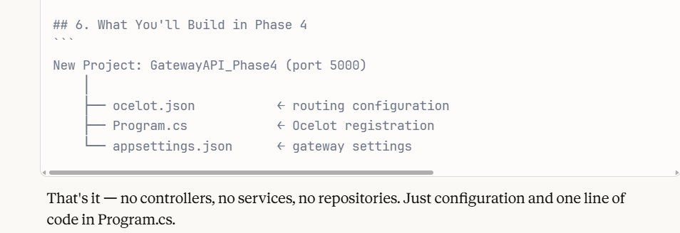
Package need to be installed – “ocelot”
That's the **only package** needed. Ocelot brings everything: - Routing - Load balancing - Rate limiting - Authentication support

API GATEWAY OCELOT FOLDER STRUCTURE ,CODE PART EXPLANATION REFER WORD FILE “OCELOT PRACTICAL”

